***Compute Area java visualizer:***

<https://liveexample.pearsoncmg.com/liang/intro12e/html/ComputeArea.html>

**Double and Float:**

*Code Example for a double (memory):*

**public** **class** ComputeArea {

**public** **static** **void** main(String[] args) {

**double** radius; // Declare radius

**double** area; // Declare area

// Assign a radius

radius = 20; // New value is radius

// Compute area

area = radius * radius * 3.14159;

// Display results

System.out.println("The area for the circle of radius " +

radius + " is " + area);

}

}

**What is a Double?**

*A double****can represent larger (and smaller) numbers than a float****and can represent them with more than twice the precision.*

**What is a Float?**

*A float data type in Java stores a decimal value with 6-7 total digits of precision. So, for example, 12.12345 can be saved as a float, but 12.123456789 can't be saved as a float.*

**Two parts of Declaring:**

*1.) Assign data Type*

*2.) Identifier*

**Primitive Data types:**

byte = 1 byte

short = 2 bytes

int = 4 bytes

long = 8 bytes

float = 4 bytes

double = 8 bytes – shows more than 2 decimal points

boolean = true or false

char = character value used with single quotes

**Non-Primitive Data Types:**

**String = two words**

**Array = All elements within an array must be of the same data type (e.g., all integers, all strings, etc.).**

**Identifiers:**

**\*Table of Contents in the code\***

**Classes: For example, MyClass.**

**Methods: For example, calculateSum().**

**Variables: For example, age, userName.**

**Packages: For example, com.example.myproject.**

**Interfaces: For example, MyInterface.**

**Version Control & IDE: GitHub and Eclipse**

*Eclipse Cheat sheet:* [*https://docs.google.com/presentation/d/1zN6ux8dob_w-8bft0ey3BpuAKhaK4x8QmyowwRUbl0A/edit?slide=id.p1#slide=id.p1*](https://docs.google.com/presentation/d/1zN6ux8dob_w-8bft0ey3BpuAKhaK4x8QmyowwRUbl0A/edit?slide=id.p1#slide=id.p1)

**Casting:**

Casting: Convert one data type to another data type

Explicit casting = manual casting of a double variable

Implicit casting = automatic casting

**Class :**

**Starts with capital letter**

public class ComputeChange {

**Comments :**

**// - one line**

**/; - multiple lines**

**Pre-defined classes:**

Predefined classes in Java are classes that are already defined and implemented by the developers of Java as part of the Java Development Kit (JDK) and Java Runtime Environment (JRE).

Ex.

Scanner

System

**Method:**

**F(x)**

*\*Class calls method\**

Main

Random

printIn

**Parameter:**

What to print (string)

NextIn(), randon()

**Return value:**

Return what the user types and return it.

Braces must be closed

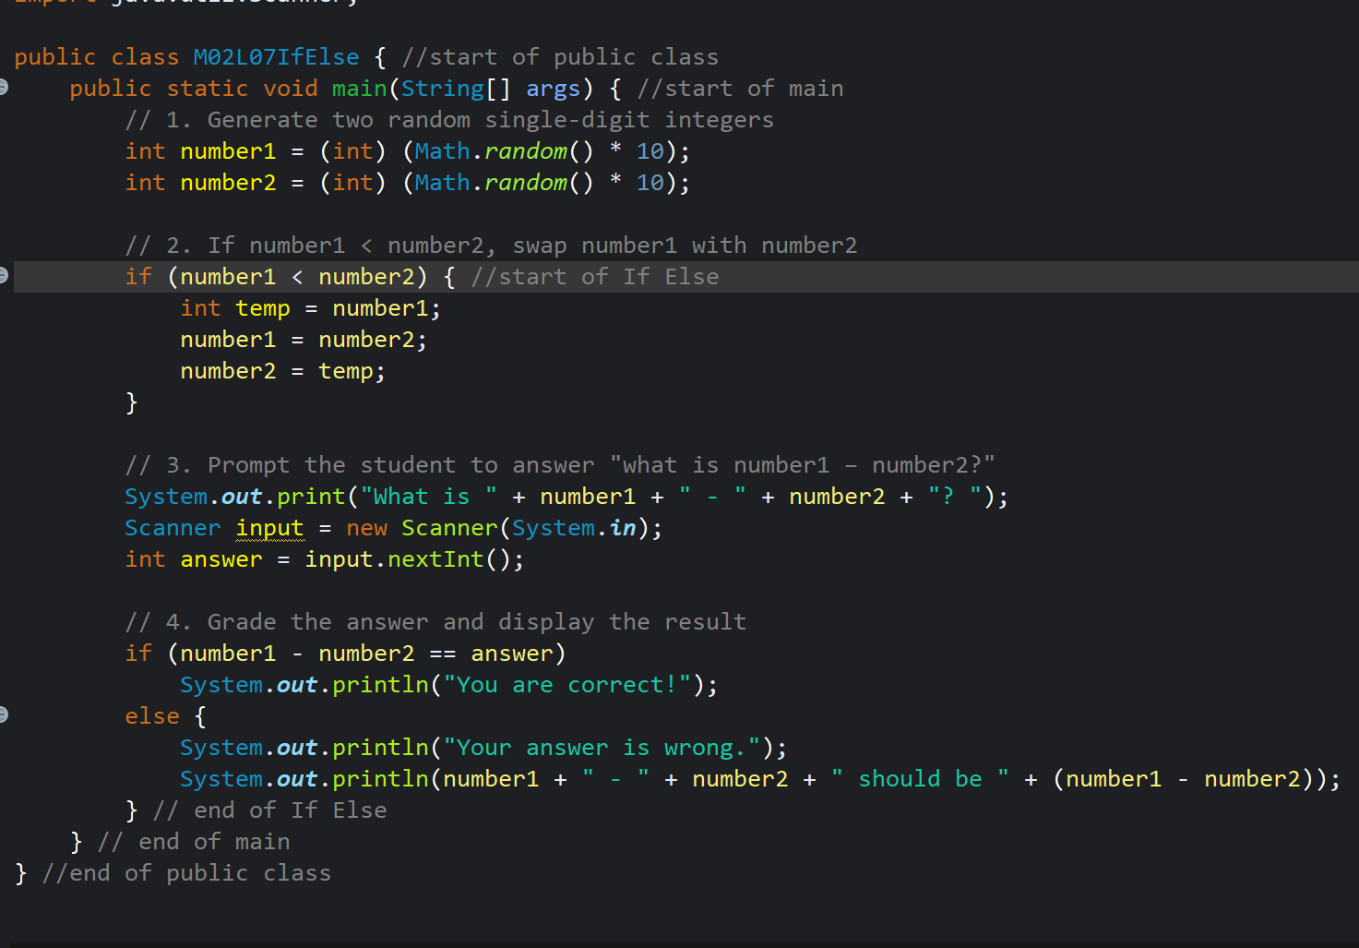

How do I know what is what?

A data type will show itself

**Grade calculator as of M02 LO8:**

